**Collections Framework hierarchy**

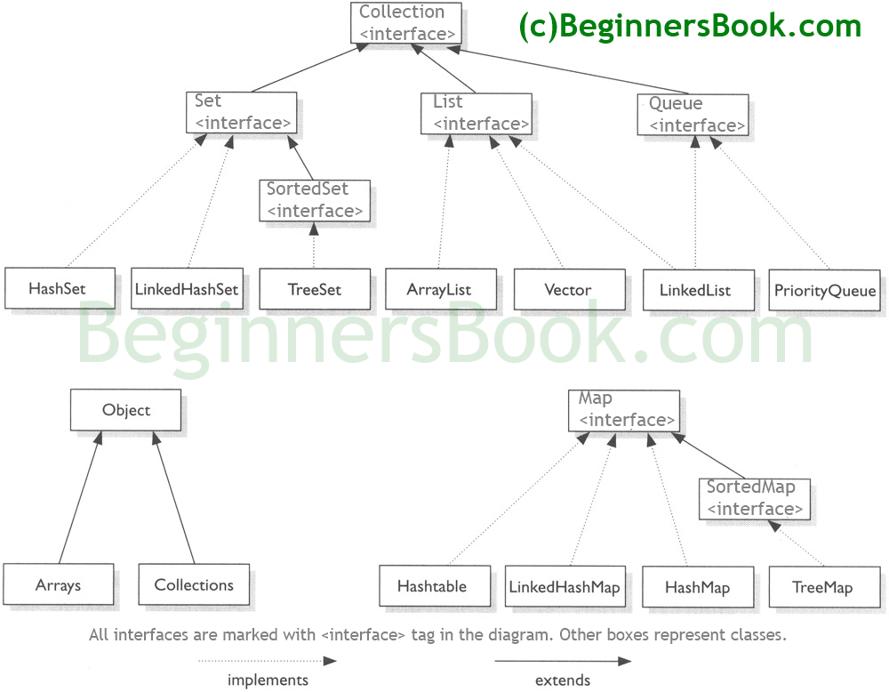

List

1. Arraylist
   1. Add
   2. Remove
   3. Set
   4. indexOf
   5. get
   6. size
   7. contains
   8. clear
   9. asList
   10. nCopies
   11. Collections.sort
   12. reverseOrder
   13. reverse